

 |  | Pieces | Size | price | Total € | Retail Price € | PICTURE
001-04-1-11 | heren koelshirt | 68 | S | 3,00 € | 204,00 € | € 39,95 |  | € 2.716,60
 | pro sport | 130 | M | 3,00 € | 390,00 € | € 39,95 |  | € 5.193,50
 |  | 200 | L | 3,00 € | 600,00 € | € 39,95 | GEEN FOTO | € 7.990,00
 |  | 129 | XL | 3,00 € | 387,00 € | € 39,95 |  | € 5.153,55
 |  | Pieces | Size | price | Total € | Retail Price € | PICTURE
001-04-2-11 | dames koelshirt | 49 | XS | 3,00 € | 147,00 € | € 39,95 |  | € 1.957,55
 | pro sport | 139 | S | 3,00 € | 417,00 € | € 39,95 |  | € 5.553,05
 |  | 134 | M | 3,00 € | 402,00 € | € 39,95 |  | € 5.353,30
 |  | 41 | L | 3,00 € | 123,00 € | € 39,95 |  | € 1.637,95
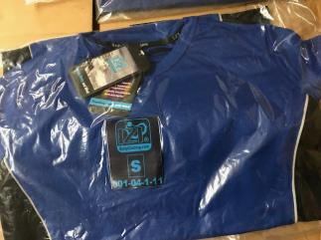
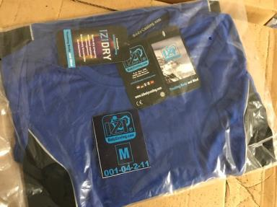

 |  | Pieces | Size | price | Total € | Retail Price € | PICTURE
001-05-1-11 | heren shirt | 18 | S | 2,50 € | 45,00 € | € 59,95 |  | € 1.079,10
 | basic sport | 44 | M | 2,50 € | 110,00 € | € 59,95 |  | € 2.637,80
 |  | 66 | L | 2,50 € | 165,00 € | € 59,95 |  | € 3.956,70
 |  | 44 | XL | 2,50 € | 110,00 € | € 59,95 |  | € 2.637,80
 |  | Pieces | Size | price | Total € | Retail Price € | PICTURE
001-05-2-11 | dames shirt | 0 | XS | 2,50 € | 0,00 € | € 59,95 |  | € 0,00
 | basic sport | 35 | S | 2,50 € | 87,50 € | € 59,95 |  | € 2.098,25
 |  | 36 | M | 2,50 € | 90,00 € | € 59,95 |  | € 2.158,20
 |  | 9 | L | 2,50 € | 22,50 € | € 59,95 |  | € 539,55
 |  | Pieces | Size | price | Total € | Retail Price € | PICTURE
002-01-1-10 | Heren Hydrogel gestikt | 48 | XXS | 5,00 € | 240,00 € | € 159,00 |  | € 7.632,00
 |  | 0 | XS | 5,00 € | 0,00 € | € 159,00 |  | € 0,00
 |  | 41 | S | 5,00 € | 205,00 € | € 159,00 |  | € 6.519,00
 |  | 38 | M | 5,00 € | 190,00 € | € 159,00 |  | € 6.042,00
 |  | 4 | L | 5,00 € | 20,00 € | € 159,00 |  | € 636,00
 |  | 0 | XL | 5,00 € | 0,00 € | € 159,00 |  | € 0,00
 |  | 0 | XXL | 5,00 € | 0,00 € | € 159,00 |  | € 0,00
 |  | 22 | XXXL | 5,00 € | 110,00 € | € 159,00 |  | € 3.498,00
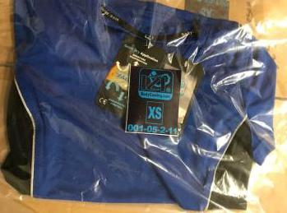
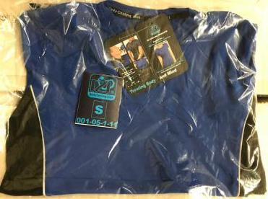
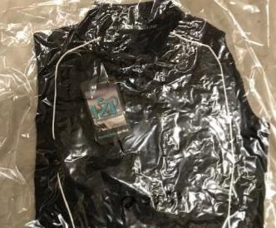
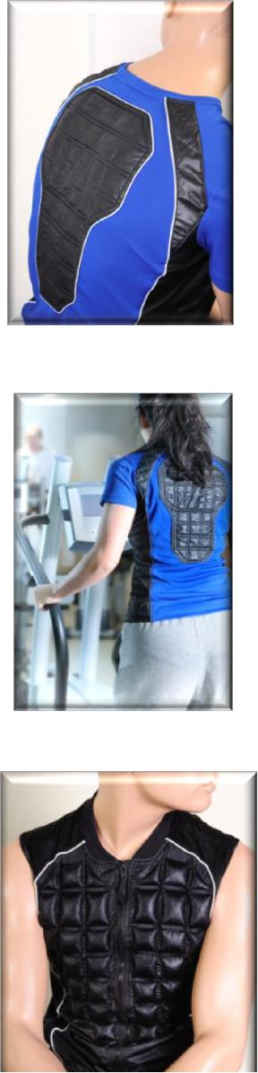
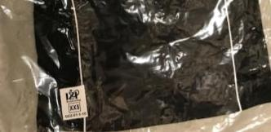
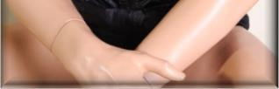
 |  | Pieces | Size | price | Total € | Retail Price € | PICTURE
001-01-1-11 | heren hydrogelvest | 87 | XS | 5,00 € | 435,00 € | € 124,95 |  | € 10.870,65
 | gestikt (NIET Deluxe) | 141 | S | 5,00 € | 705,00 € | € 124,95 |  | € 17.617,95
 |  | 172 | M | 5,00 € | 860,00 € | € 124,95 |  | € 21.491,40
 |  | 14 | L | 5,00 € | 70,00 € | € 124,95 |  | € 1.749,30
 |  | 10 | XL | 5,00 € | 50,00 € | € 124,95 |  | € 1.249,50
 |  | 0 | XXL | 5,00 € | 0,00 € | € 124,95 |  | € 0,00
 |  | Pieces | Size | price | Total € | Retail Price € | PICTURE
001-01-2-10 | dames hydrogelvest | 49 | XS | 5,00 € | 245,00 € | € 124,95 |  | € 6.122,55
 | gestikt (NIET Deluxe) | 58 | S | 5,00 € | 290,00 € | € 124,95 |  | € 7.247,10
 |  | 94 | M | 5,00 € | 470,00 € | € 124,95 |  | € 11.745,30
 |  | 71 | L | 5,00 € | 355,00 € | € 124,95 |  | € 8.871,45
 |  | 27 | XL | 5,00 € | 135,00 € | € 124,95 |  | € 3.373,65
 |  | 51 | XXL | 5,00 € | 255,00 € | € 124,95 |  | € 6.372,45
 |  | Pieces | Size | price | Total € | Retail Price € | PICTURE
001-03-1-11 | unisex koelvest | 218 | S | 5,00 € | 1.090,00 € | € 79,95 |  | € 17.429,10
 | fleece | 0 | M | 5,00 € | 0,00 € | € 79,95 |  | € 0,00
 | zwart | 0 | L | 5,00 € | 0,00 € | € 79,95 |  | € 0,00
 |  | 196 | XL | 5,00 € | 980,00 € | € 79,95 |  | € 15.670,20
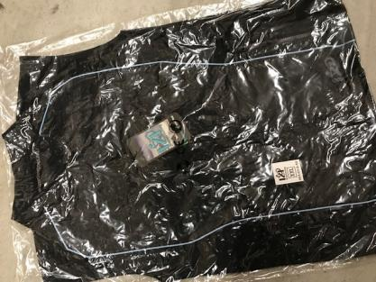
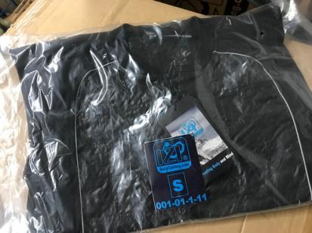
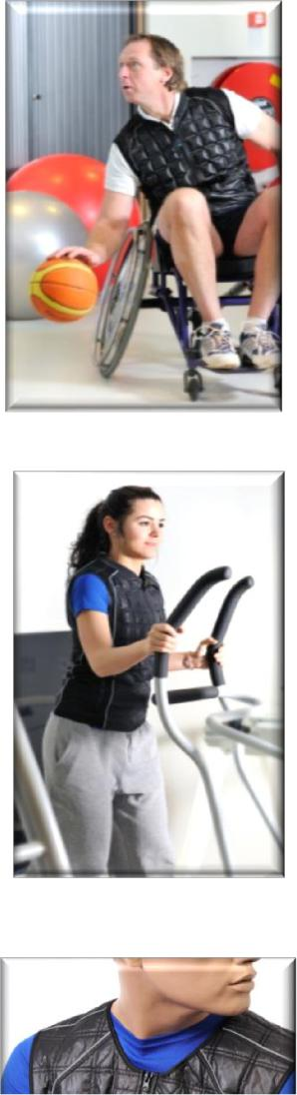
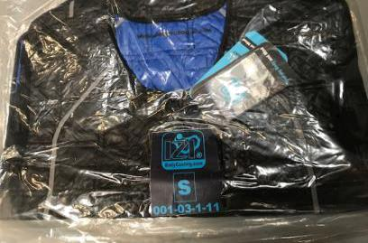  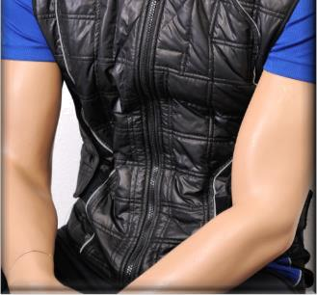 |  | 0 | XXL | 5,00 € | 0,00 € | € 79,95 |  | € 0,00
 |  | Pieces | Size | price | Total € | Retail Price € | PICTURE
001-02-1-11 | industrie koelvest | 0 | XS | 5,00 € | 0,00 € | € 89,95 |  | € 0,00
 | fleece | 496 | S | 5,00 € | 2.480,00 € | € 89,95 |  | € 44.615,20
 | oranje + reflective tape | 0 | M | 5,00 € | 0,00 € | € 89,95 |  | € 0,00
 |  | 0 | L | 5,00 € | 0,00 € | € 89,95 |  | € 0,00
 |  | 486 | XL | 5,00 € | 2.430,00 € | € 89,95 |  | € 43.715,70
 |  | Pieces | Size | price | Total € | Retail Price € | PICTURE
001-06-1-11 | koelbrace - upper leg | 378 | 1 size fit all | 3,50 € | 1.323,00 € | € 45,00 |  | € 17.010,00
 | koelbrace - lower leg | 327 | 1 size fit all | 3,50 € | 1.144,50 € | € 45,00 |  | € 14.715,00
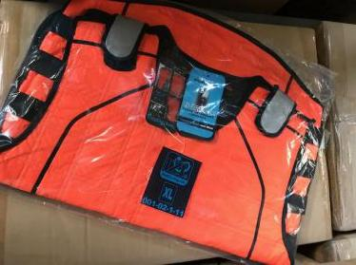
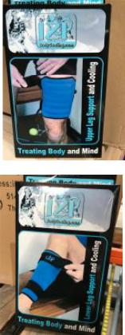
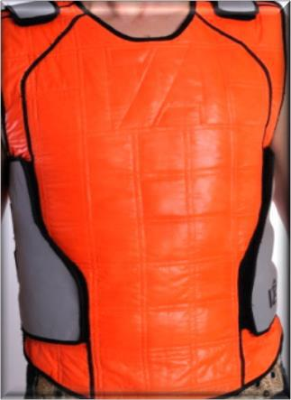
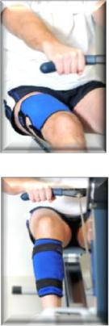
 | koelbrace - foot | 317 | 1 size fit all | 3,50 € | 1.109,50 € | € 45,00 |  | € 14.265,00
 | koelbrace - knee | 242 | 1 size fit all | 3,50 € | 847,00 € | € 45,00 |  | € 10.890,00
 | koelbrace - right wrist | 181 | 1 size fit all | 3,50 € | 633,50 € | € 45,00 |  | € 8.145,00
 | koelbrace - left wrist | 78 | 1 size fit all | 3,50 € | 273,00 € | € 45,00 |  | € 3.510,00
 | koelbrace - elbow | 378 | 1 size fit all | 3,50 € | 1.323,00 € | € 45,00 |  | € 17.010,00
 |  | Pieces | Size | price | Total € | Retail Price € | PICTURE
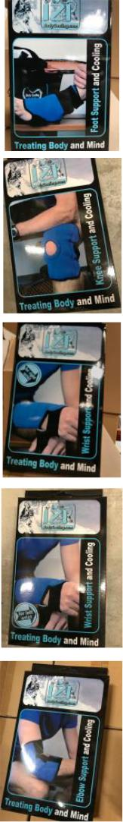
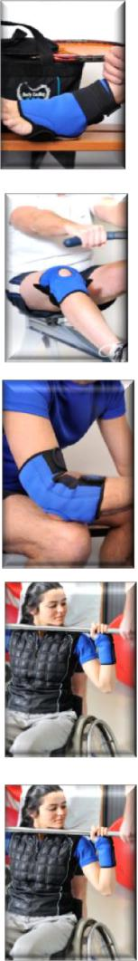
DIS-001-102-DOG-2014 | Display dog koelproducten groot |  |  | 300 | ND | 2,50 € | 750,00 € | NVT | NVT
DIS-001-077-DOG-2014 | Display dog koelproducten klein |  |  | 252 | ND | 2,50 € | 630,00 € | NVT | NVT
 |  |  |  | Pieces | Size | price | Total € | Retail Price € | PICTURE
Fleece 01 | dogcooling blanket DELUXE |  |  | 24 | S | 2,50 € | 60,00 € | € 34,95 |  | € 838,80
 | sporty blue |  |  | 48 | M | 3,00 € | 144,00 € | € 44,95 |  | € 2.157,60
 | (latest version) |  |  | 48 | L | 3,50 € | 168,00 € | € 54,95 |  | € 2.637,60
 |  |  |  | 38 | XL | 4,00 € | 152,00 € | € 64,95 |  | € 2.468,10
 |  |  | Pieces |  | Size | price | Total € | Retail Price € | PICTURE
001-15-1-12 | Deluxe dog cooling blank |  | red | blue
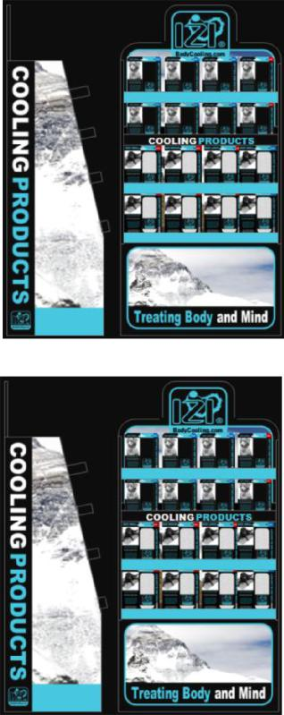
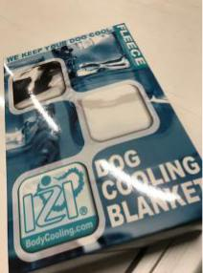
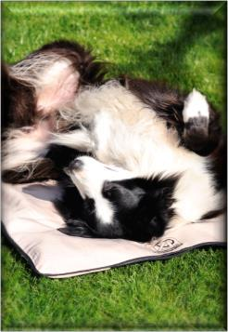
 |  | 35 | 42 | XS | 2,00 € | 154,00 € | € 24,95 |  | € 1.921,15
 |  | 28 | 0 | S | 2,50 € | 70,00 € | € 34,95 |  | € 978,60
 |  | 28 | 0 | M | 3,00 € | 84,00 € | € 44,95 |  | € 1.258,60
 |  | 30 | 0 | L | 3,50 € | 105,00 € | € 54,95 |  | € 1.648,50
 |  | 52 | 2 | XL | 4,00 € | 216,00 € | € 64,95 |  | € 3.507,30
 |  | Pieces |  | Size | price | Total € | Retail Price € | PICTURE
001-14-1-12 | dog cooling blanket | red | blue
 |  | 10 | 0 | XS | 1,50 € | 15,00 € | € 19,95 |  | € 199,50
 |  | 17 | 0 | S | 2,00 € | 34,00 € | € 29,95 |  | € 509,15
 |  | 42 | 0 | M | 2,50 € | 105,00 € | € 39,95 |  | € 1.677,90
 |  | 13 | 0 | L | 3,00 € | 39,00 € | € 49,95 |  | € 649,35
 |  | 0 | 0 | XL | 3,50 € | 0,00 € | € 59,95 |  | € 0,00
 |  |  | Pieces | Size | price | Total € | Retail Price € | PICTURE
001-13-1-13 | dogcooling coat blue |  | 5 | XS | 2,00 € | 10,00 € | € 19,95 |  | € 99,75
 | stitched |  | 2 | S | 2,50 € | 5,00 € | € 29,95 |  | € 59,90
 |  |  | 9 | M | 3,00 € | 27,00 € | € 39,95 |  | € 359,55
 |  |  | 23 | L | 3,50 € | 80,50 € | € 49,95 |  | € 1.148,85
 |  |  | 15 | XL | 4,00 € | 60,00 € | € 59,95 |  | € 899,25
 |  |  | Pieces | Size | price | Total € | Retail Price € | PICTURE
001-13-1-13 | dogcooling coat red |  | 16 | XS | 2,00 € | 32,00 € | € 19,95 |  | € 319,20
 | stitched |  | 14 | S | 2,50 € | 35,00 € | € 29,95 |  | € 419,30
 |  |  | 12 | M | 3,00 € | 36,00 € | € 39,95 |  | € 479,40
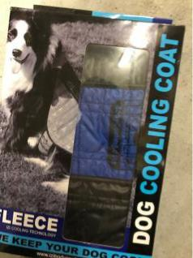
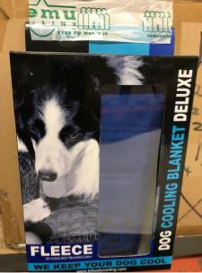

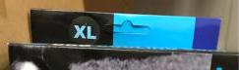
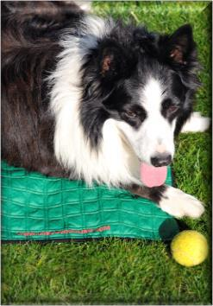
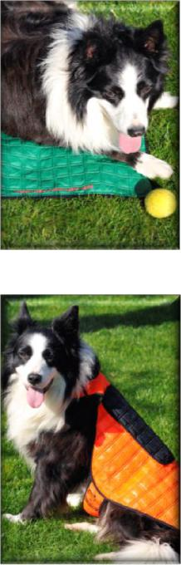
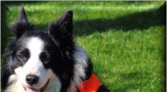
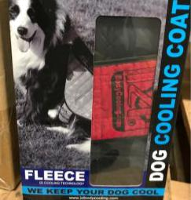  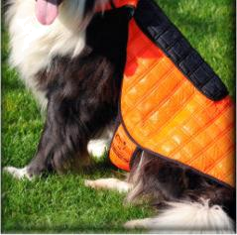 |  |  | 27 | L | 3,50 € | 94,50 € | € 49,95 |  | € 1.348,65
 |  |  | 16 | XL | 4,00 € | 64,00 € | € 59,95 |  | € 959,20
 |  |  | Pieces | Size | price | Total € | Retail Price € | PICTURE
004-01-14 | Blue Bandana Hydrogel | SEALED | 729 | S | 1,50 € | 1.093,50 € | € 17,95 |  | € 13.085,55
 |  |  | 813 | M | 2,00 € | 1.626,00 € | € 17,95 |  | € 14.593,35
 |  |  | 864 | L | 2,50 € | 2.160,00 € | € 17,95 |  | € 15.508,80
 |  |  | Pieces | Size | price | Total € | Retail Price € | PICTURE
003-01-14 | Red Bandana Hydrogel | SEALED | 716 | S | 1,50 € | 1.074,00 € | € 17,95 |  | € 12.852,20
 |  |  | 902 | M | 2,00 € | 1.804,00 € | € 17,95 |  | € 16.190,90
 |  |  | 798 | L | 2,50 € | 1.995,00 € | € 17,95 |  | € 14.324,10
 |  |  | Pieces | Size | price | Total € | Retail Price € | PICTURE
002-01-14 | Blue Dog cooling collar | SEALED | 634 | S | 1,00 € | 634,00 € | € 12,95 |  | € 8.210,30
 |  |  | 779 | M | 1,50 € | 1.168,50 € | € 12,95 |  | € 10.088,05
 |  |  | 788 | L | 2,00 € | 1.576,00 € | € 12,95 |  | € 10.204,60
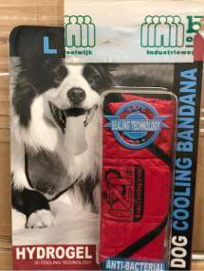
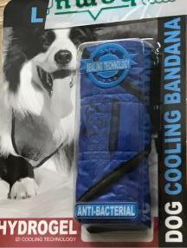
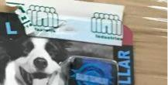
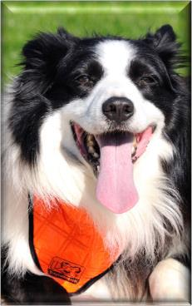
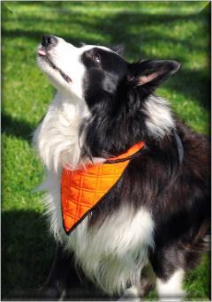
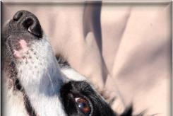
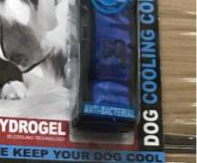
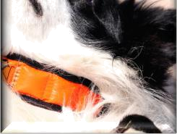
 |  |  | Pieces | Size | price | Total € | Retail Price € | PICTURE
001-01-14 | Red Dog cooling collar | SEALED | 660 | S | 1,00 € | 660,00 € | € 12,95 |  | € 8.547,00
 |  |  | 819 | M | 1,50 € | 1.228,50 € | € 12,95 |  | € 10.606,05
 |  |  | 812 | L | 2,00 € | 1.624,00 € | € 12,95 |  | € 10.515,40
 |  |  | Pieces | Size | price | Total € | Retail Price € | PICTURE
001-07-1-11 | Neck |  | 100 | 1 size fit all | 1,00 € | 100,00 € | € 12,95 |  | € 1.295,00
 | Wrist |  | 139 | 1 size fit all | 1,00 € | 139,00 € | € 9,95 |  | € 1.383,05
 | Head |  | 270 | 1 size fit all | 1,00 € | 270,00 € | € 12,95 |  | € 3.496,50
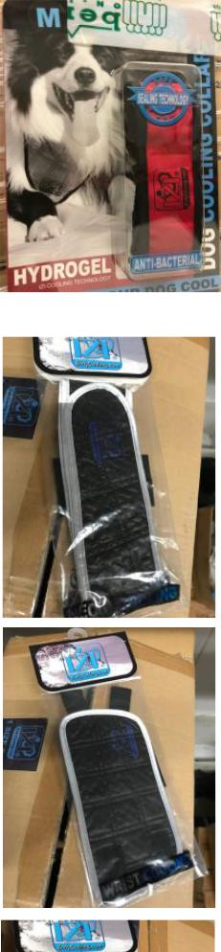
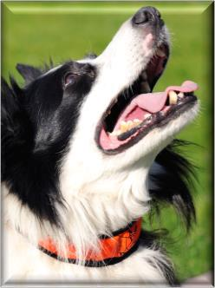
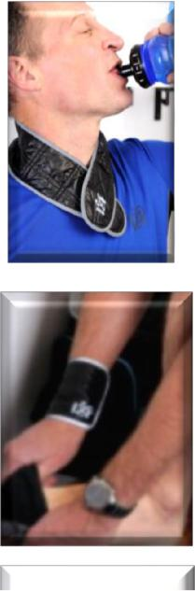


16337 41.891,00 € € 556.122,45

